Visual Studio Installation: Configuring Universal Windows Platform development  
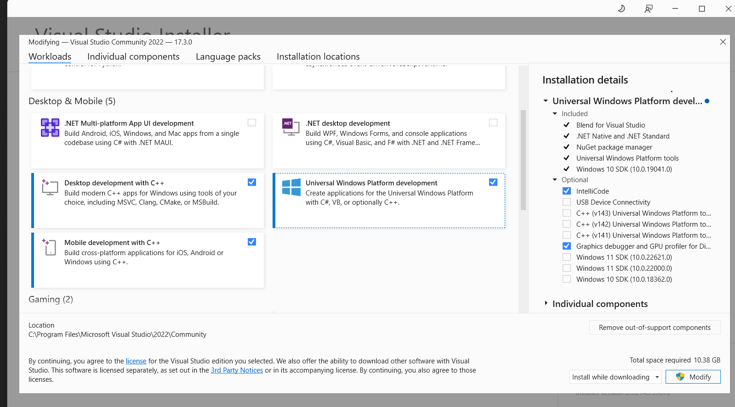

Creating new project for Visual Studio after installation:

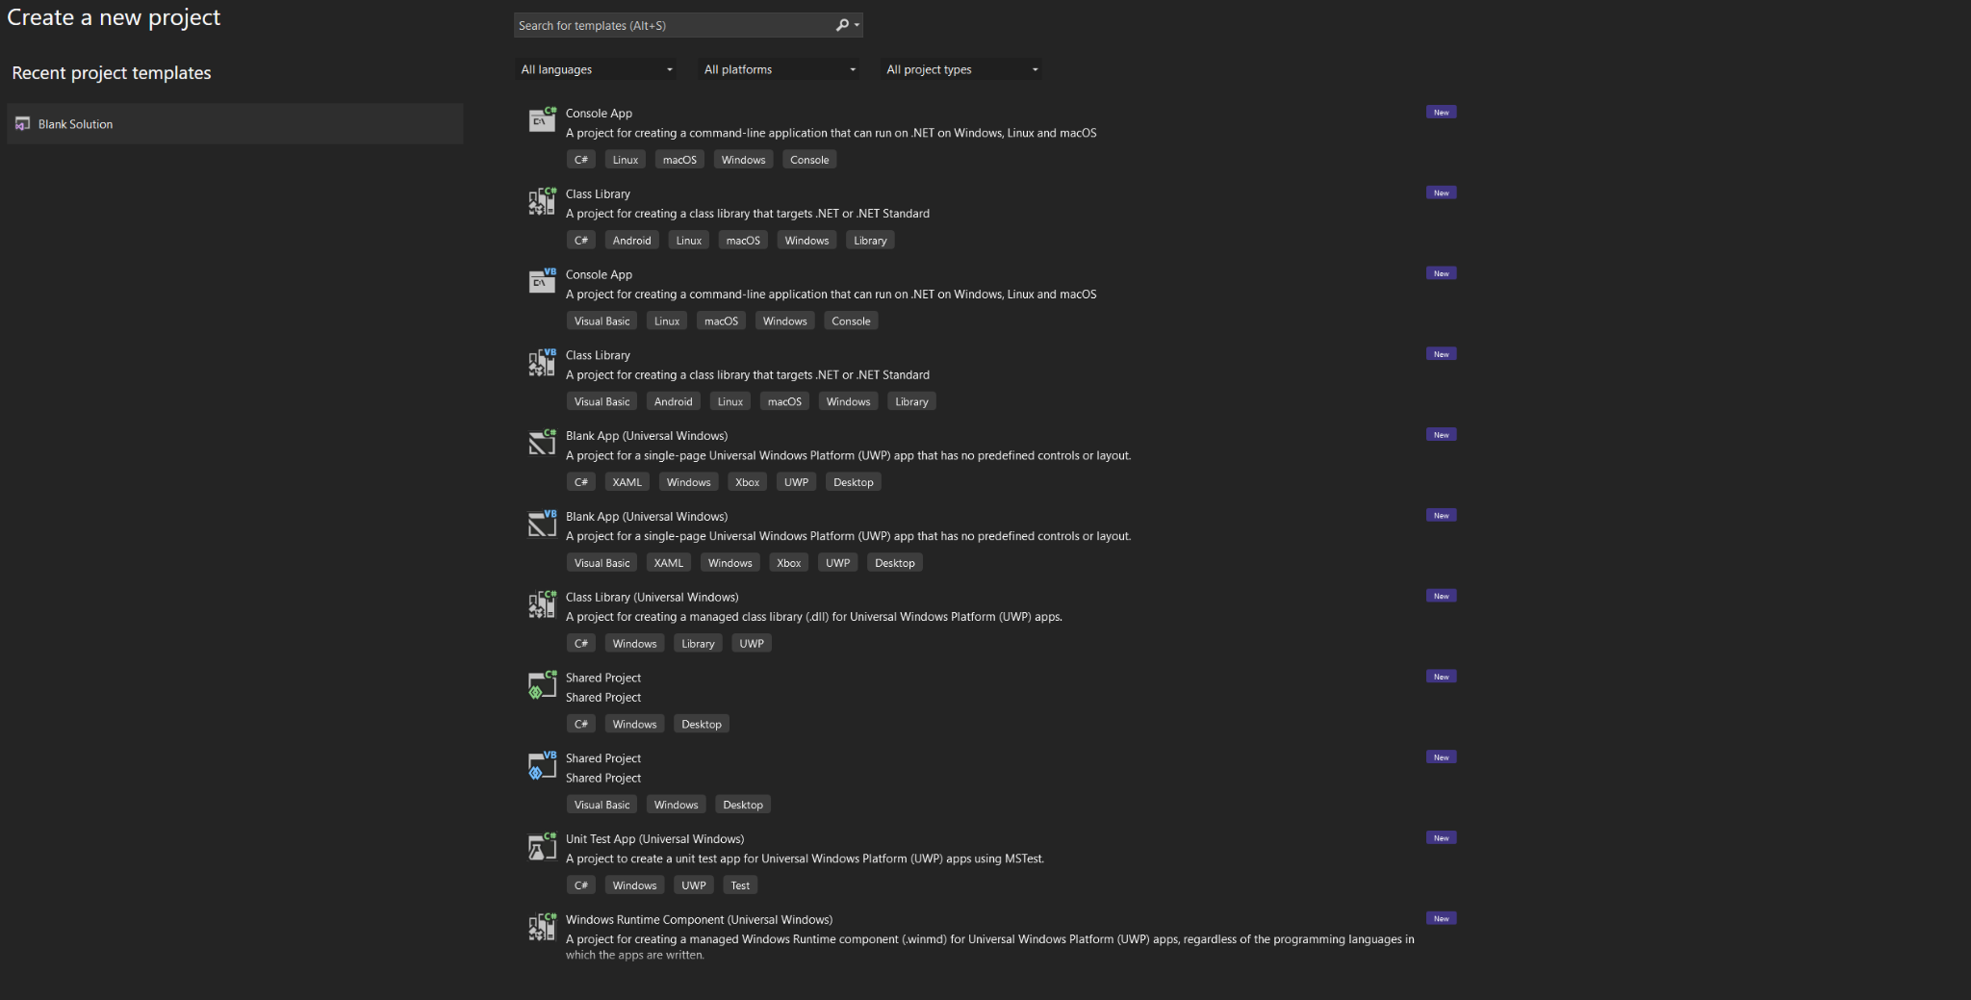

Further installation for C++ development

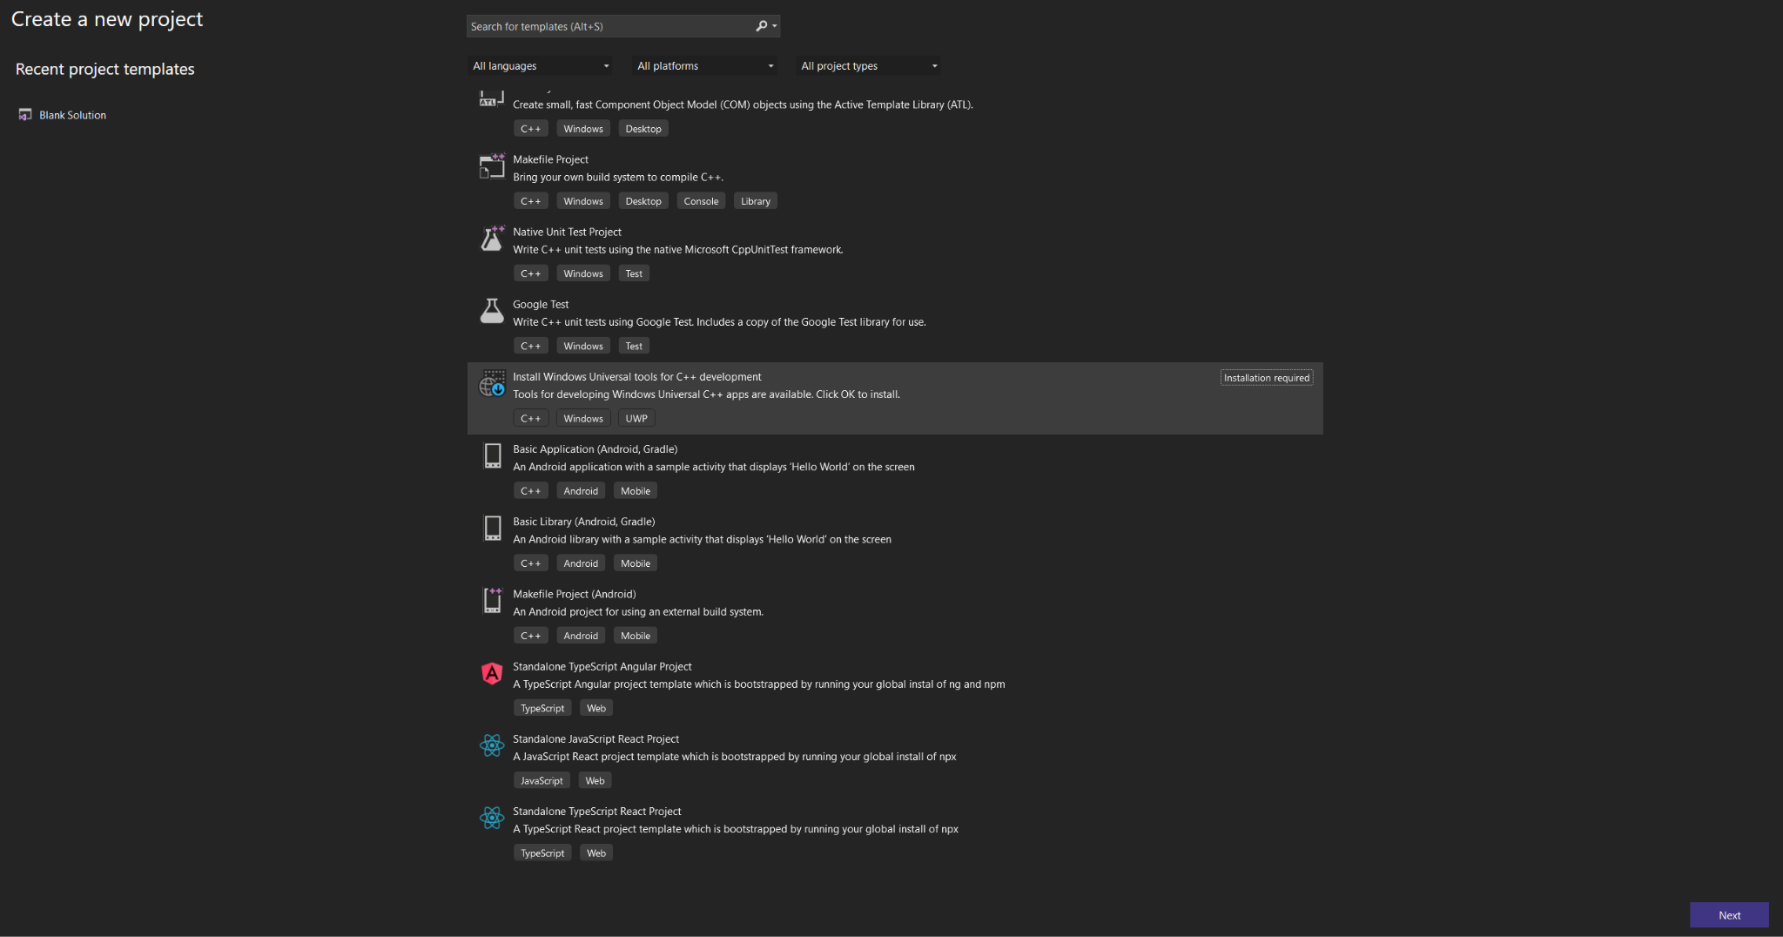

After installation for C++ development, operating Visual Studio screen

